|  |  |
| --- | --- |
| ***Dates to Remember*** | |
| *Tuesdays* | *6.30pm Interchurch Volleyball* |
| *Thursdays* | *Te Hahi Combined Churches Prayer - 7am AOG Church* |
|  |  |



**Church Office Hours: 9am - 12noon, Mon - Fri** (excluding public holidays).

**‘Prayer Chain’ –** Urgent matters for confidential prayer support, can be referred to the Prayer Chain Group. Contact Joy McHardy or Val Judd.

**Tuesday 'Prayer For the Nation’** – 11am at Janet Burgess’s house. For more info contact Janet Burgess or Gretchen Norman.

**Tuesday Afternoon Bible Study** – Meets at 1.30pm in the Church House. For more info contact Maureen Wilson.

**Wednesday ‘Mens Breakfast’**- Meets for breakfast at 6.45am in the Church House. For more info contact Paul Cosson.

**Thursday ‘Womens Breakfast’** – Meets for breakfast at 7am in the Church House. For more info contact Amanda Lewis.

**Women's ‘Growth Group’** – Taking a break over the school holidays. Next meeting will be 1pm on Thursday 6th May, in the Church House.  If you are interested in joining please contact Nicola Hawkins.

**Covid Vaccines** – We know that there are many of you that have concerns and questions about the Covid vaccines. The Interchurch Bioethics Council have produced a paper to assist our understanding by answering some frequently asked questions. You can read this on the Church Noticeboard.

**Giving/Tithing -** If you wish to tithe or make a donation to Mangapapa Church, our account number is: Mangapapa Church, 03-0638-0381084-00. Please make sure you say ‘tithe’ or ‘donation’ in the reference. If you would prefer to give using our ‘Envelope’ system, then see Jenny Phin who will set you up with envelopes allocated to you.

**Sunday 18th April 2021**

**10am: All Ages Service**

**“Resurrection Revelations With Jesus”**

**Leading: Leigh McGurk Preaching: Stewart Patrick**

**Duty Elder: Llew Paul**

____________________________________________________

|  |  |  |
| --- | --- | --- |
|  | *Today* | *Next Sunday 25th April* |
| Greeters | *M Wilson, L McAra* | *B & A Hall* |
| Explorers Crèche | *School Hols / Parents* | *School Hols / Parents* |
| Matrix | *School Hols* | *School Holidays* |
| Ministry Team | *A Clement* | *J Newman* |
| Cups of Tea | *N & C Coffey, P Oram* | *B Corlett, J Dyas, M Smith* |
| Flowers | *A Lewis* | *G Sharp* |
| AV & Sound | *D Russell / P Cosson* | *R Nelson / P Cosson* |
| Counters | *N Coffey* | *A Radcliffe* |

**Church Leader:** PaulaLevy **Office 06** 867-9604 **Cell** 021 140-4667

**E-mail** [**paula@mup.org.nz**](mailto:paula@mup.org.nz)

**Church Office 06** 867-9604 **9am – 12noon**

**E-mail** [**office@mup.org.nz**](mailto:office@mup.org.nz) **Website:** [**www.mup.org.nz**](http://www.mup.org.nz)

Mangapapa Church, P.O. Box 2146 Gisborne 4040

**Elders Team**

Andrew Russell: 027 815-1635 Rodney Judd 06 863-2400 Llew Paul: 022 052 8297

__­­­­­­­­­­­­­­­­­­­­­­­­­­­­­­­­__­­­­­­­­­­­___________________________________________________________________________­­­­­

*Children stay in during the service. Activity sheets on the table at the back.*

**Paula writes…**

****Hi everyone,

I am away this Sunday. Thanks to Leigh and Stewart for leading our service today. Dione will be on leave this week, but Marie will be keeping things going in the office. I will be away the following week.

Elders update:   
We have been prayerfully looking at expanding our Eldership Team. Last year we took on Alan Clements and Anna Alder as Associate Elders, giving time to discern whether they could become Elders. Anna was a real blessing and served in many ways but has decided to not have her name go forward. The Eldership team now wish to recommend to you Al Clements to be considered for Eldership.

In our Presbyterian system, we need to notify the congregation for at least two weeks of this intention before we have a congregational vote. Below Al has written a little about himself, if you do not know him well.

On Sunday the 9th of May we will have a congregational vote straight after our morning service in regards to this.

**Blessings, Paula**

-----------------------------------------------------------------------

**Al Clements writes …**

For those who do not know me, I would like to give you a brief introduction. I am 65 years old, and I came to Gisborne in 1978. Met and married Sal in 1986. We have 3 children and 2 grandchildren. I have been working as a gardener for most of my life. When I was 40 years old, God the Spirit called, spoke, touched my life and I was born anew. Jesus invited me into His life as His friend. Through many ups and downs I still stumble on the journey with Him. I first came to Mangapapa Church in 2001. Had a couple of years in the wilderness. Come back in God’s grace and love. Been here ever since. I am deeply committed to Jesus and His body, the church. I have a heart to see people’s lives transformed by the love and truth of Jesus and believe Jesus sets people free. I long to see healing and restoration in people’s lives.

**End Of Year Giving Receipts** – We will be endeavouring to get your end of year giving receipts out to you by the end of April. These will be getting emailed to you, so if you would rather have a printed copy could you please let the office know.

Our ‘All-Ages’ worship themetoday; **'Resurrection Revelations with Jesus'**,comes fromthe Lectionary Reading for today, Luke 24:36-49. This is the first of several occasions over 40 days where Jesus appears to the disciples before His Ascension to the Father. We will consider Peter’s story in particular, as he felt unworthy before he followed Jesus the first time, and unworthy at what he thought was the end, when he denied Jesus, but wait! There is much more… Then as we are looking at some characters of the ‘Old Testament’, we will see ‘Gideon’ (Judges ch.6), in the light of the Resurrection Revelation too. He and Peter and you, yes you, have much in common.

**Update Of Church Directory** - We are at present looking to update our Directory. If you have changes to your details could you please let the office know, or if you are not in the 2020 one and would like to be in the 2021 one, please hand in your details and see Marilyn Patrick for a photo. Thank you.

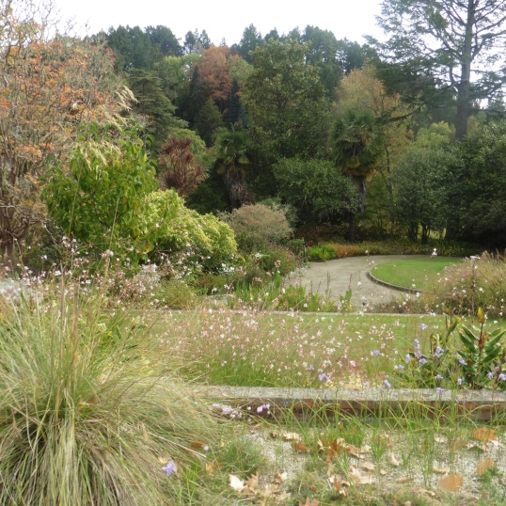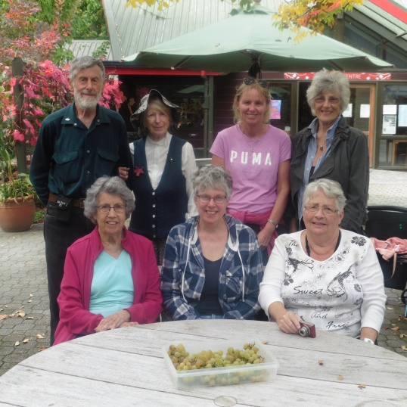

**Autumn At The Arboretum** – Six women and one man enjoyed the Autumnal sights, sounds and smells at Eastwoodhill Arboretum last Friday.  It was a beautiful, still day to appreciate the variety of trees and flowers that God created for our pleasure.  It was also a lovely way to get to know one another better.